Daily Task: MongoDB CRUD Operations – Language Proficiency Exams

Aim:
To design and perform CRUD operations in MongoDB using Python for storing and managing information about language proficiency exams required for university admissions.

Real-Time Scenario:
In this task, I built a backend system using MongoDB to store, manage, and retrieve information about various language proficiency exams such as IELTS, TOEFL, and Duolingo. These exams differ in their formats, scoring systems, and total score ranges. As a Data Engineer, I created this system to help administrators easily manage this data and allow other applications or users to access accurate, up-to-date exam information. Below is a breakdown of each CRUD (Create, Read, Update, Delete) operation used in this task:

What I Did (As a Data Engineer):

1)insertOne() – Adding a Single Exam Record
The insertOne() method was used to add a single document into the MongoDB collection. In this context, I inserted a language exam record that includes fields like the exam title (e.g., “IELTS”), the format (e.g., “Computer-based”), the scoring system (e.g., “Band-based”), and the total score (e.g., 9). This operation is useful when administrators want to add one new exam to the database without disturbing the rest of the data.
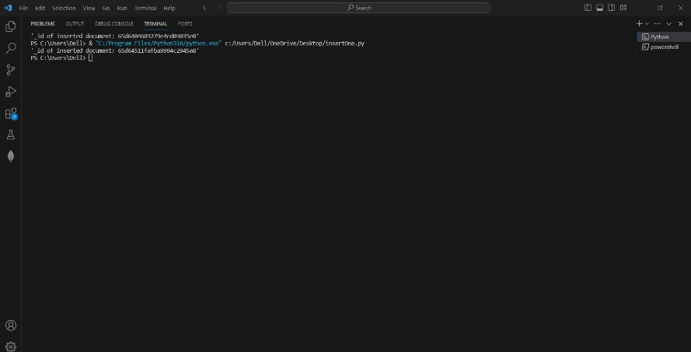
2) insertMany() – Adding Multiple Exam Records at Once
To add more than one language exam at the same time, I used the insertMany() function. I inserted multiple documents in one go for example, entries for TOEFL, Duolingo, and PTE exams, each having their own format, scoring method, and maximum scores. This method helps save time and makes data loading faster and more efficient, especially when onboarding multiple exams at once.
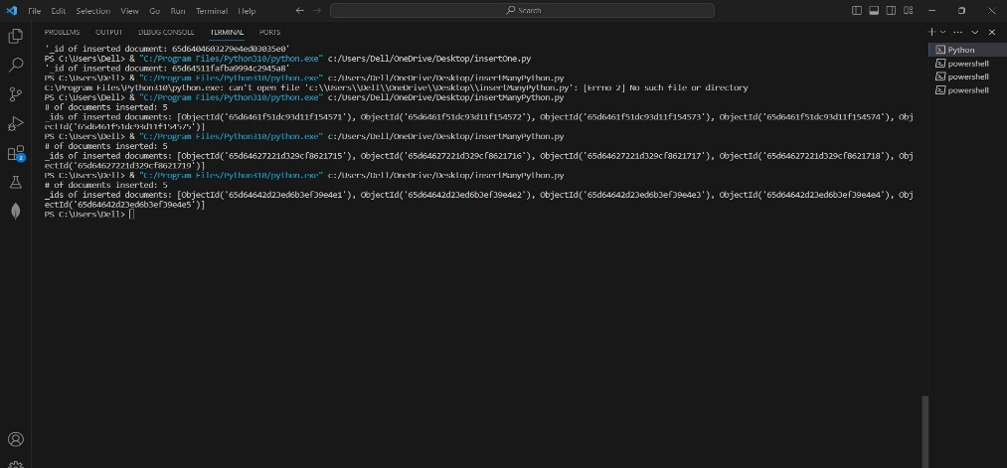

3) find() – Retrieving a Single Exam Record
To retrieve specific information from the database, I used the find() method. By passing a filter condition such as {title: "IELTS"}, I was able to retrieve that particular document. This method is especially useful when a system or user needs to fetch details about one specific exam for example, when a student selects an exam and wants to view its details on the university portal.
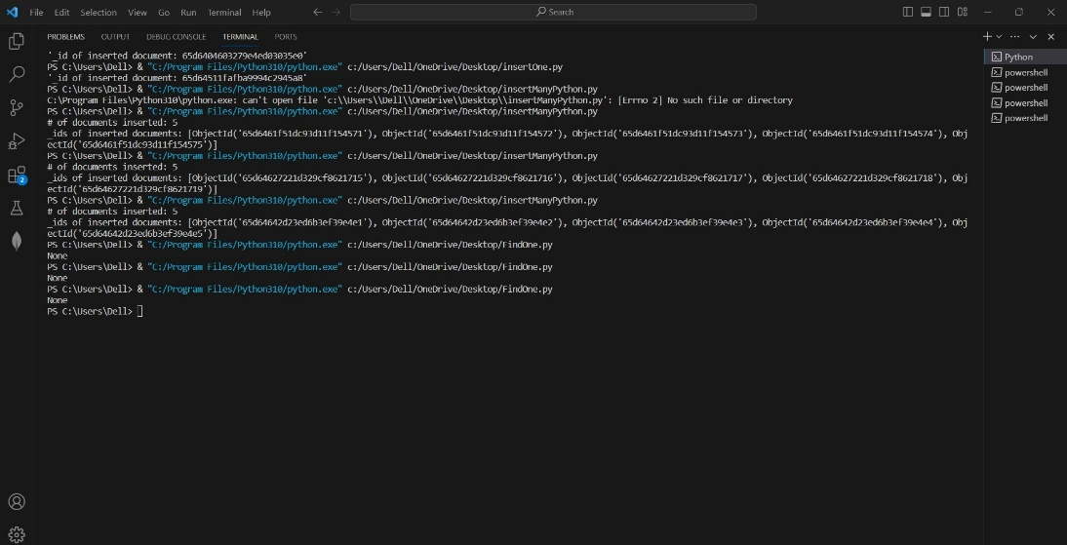

4) find() – Retrieving Multiple Exam Records
In cases where I needed to display all exams or exams matching a condition, I used the find() method again—this time without strict filters or with broader conditions. For example, I could retrieve all exams that use “Band-based” scoring. This operation helps build features like a dropdown list for exams or reports comparing exam formats and scoring.
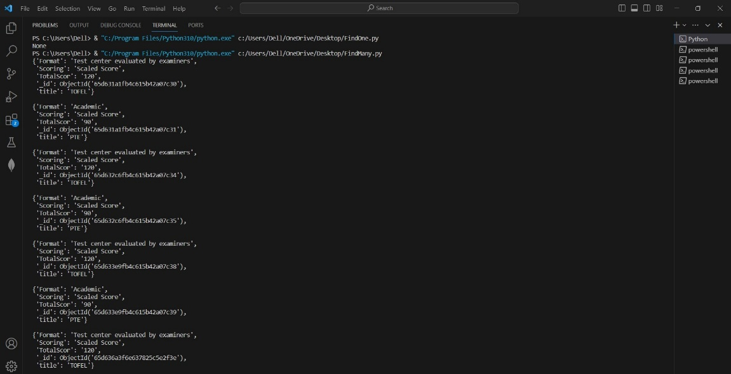

5) updateOne() – Updating a Single Exam's Information
Sometimes, the details of an exam might change—for example, the total score of an exam might be updated from 100 to 120. I used the updateOne() method to change a specific field of a single document. This is very useful for correcting mistakes or reflecting changes in exam structures without modifying other data.
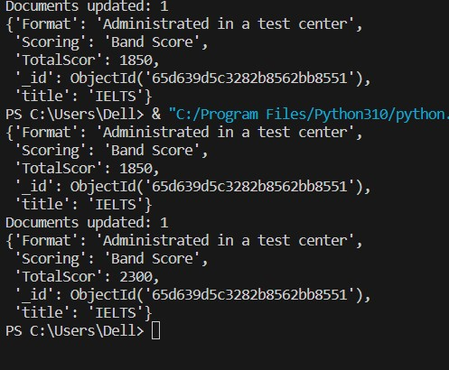
6) updateMany() – Updating Multiple Exams at Once
When there was a need to update many documents together—for example, changing the format of all exams from “Paper-based” to “Computer-based”—I used the updateMany() function. This operation makes bulk editing easy and consistent, ensuring that all matching records are updated at the same time, which is essential in large-scale data systems.
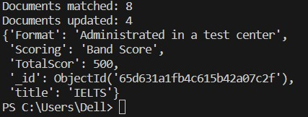

7) deleteOne() – Deleting a Specific Exam Record
To remove a particular exam from the database—like when an exam is no longer accepted by universities—I used the deleteOne() method. This method ensures only the selected document is deleted, keeping the rest of the data intact and safe.
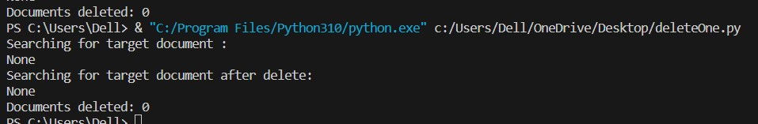

8) deleteMany() – Deleting Multiple Exam Records
Finally, I used the deleteMany() method when I needed to remove multiple exam entries from the collection. For instance, if several outdated exams shared the same format or scoring system, I could delete them all in one step. This is useful for regular database maintenance and cleanup activities.
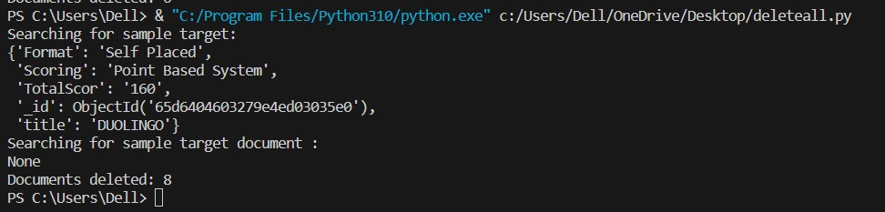
Conclusion :
In this task, I learned how to use MongoDB to add, view, update, and delete data using Python. I applied these operations to manage real-time information about language proficiency exams like IELTS and TOEFL. Each operation helped me understand how to handle exam data in a clean and organized way.
This kind of backend system is useful for universities or educational platforms where exam details need to be updated or viewed often. As a data engineer, this task gave me hands-on experience with NoSQL databases and showed me how to build a basic data management system that can support real applications.

